Market Control System

SRS

Introduced By Group G19

|  |  |  |  |  |
| --- | --- | --- | --- | --- |
| version | *Written by* | *Reviewed by* | *Approved by* | *Data* |
| 0.5 | Ahmed Khaled , Ahmed Sayed Galal, Ahmed Samir. | Ahmed Khaled | Ahmed Khaled | 26-11-2018 |
| 1.0 | Ahmed Khaled , Ahmed Sayed Galal, Ahmed Samir, Ahmed Sherif, Shaymaa Hamd. | Ahmed Khaled, Ahmed Sayed Galal | Ahmed Khaled, Ahmed Sherif | 1-12-2018 |
| 2.0 | Ahmed Khaled , Ahmed Sayed Galal, Ahmed Samir, Ahmed Sherif, Shaymaa Hamd, Abdelrahman Bishr. | Ahmed Khaled, Ahmed Sherif | Ahmed Khaled, Ahmed Sherif | 2-12-2018 |
| 3.0 | Ahmed Khaled , Ahmed Sayed Galal, Ahmed Samir, Ahmed Sherif, Shaymaa Hamd. | Ahmed Khaled | Ahmed Sherif | 3-12-2018 |

**System description**

# Introduction:

## 1.1. Purpose

It’s a system that is used in shopping centers, markets malls, etc.… This system makes it easy for the managers to control the place circumstances, get regular feedback about the incomes and outcomes of the market and make the place much more secure

## 1.2. Scope of Project

* **Casher system**: System can do calculation, ability to get the price of the product by its barcode, store in the memory the current amount of money in the memory and open the locker by password hence the security is enhanced and getting feedback became easier.
* **Air-condition** **System:** System controls the temperature of the market by using sensors.
* **Security System:** Dedicates to secure place with cameras inside and outside the market and with alarm devices.
* **Doors System:** controls opening and closing the doors of the market. The main doors open by password and the internal doors open automatically using sensors that can detect people motion.

## 1.3. Overview of Document

* The next chapter, the system Description section, of this document gives an overview of the functionality of our project. It describes the informal requirements and is used to establish a context for the technical requirements specification.
* The third chapter, system users section, of this document gives the user role descriptions and is written primarily for the developers and describes in technical terms the details of the functionality of the product.
* The fourth chapter, system modules section, of this document Provide module description. Use block or context diagram to illustrate external and sub-modules. Use activity diagram, state machine diagram, data flow diagrams to illustrate module operations.
* The fifth chapter, system functions section, of this document Provides function description. And function of inputs. And function of outputs. And function required conditions to work. And new conditions after work
* The sixth chapter, system models section, of this document makes only mandatory diagram to illustrate overall system interaction or to explain complex scenarios
* The seventh chapter, non functional requirements section, of this document gives Non functional security, usability, technology, performance, development, delivery and operation requirements description
* The eighth chapter, domain requirements section, of this document Explains domain requirement or constrain.
* The ninth chapter, system interface section, of this document provides with user interfaces, communication interfaces, hardware interfaces, and any others interfaces.
* Every section of the document describe the same software product in its entirety, but are intended for different audiences and thus use different language

# 1.5. References

1) *ANSI/IEEE Std 830-1998, IEEE Recommended Practice for Software Requirements Specifications*

s

(2)*ANSI/IEEE Std 1233-1996, IEEE Guide for Developing System Requirements*

*Specifications*

1. [*http://www.softwareengineering-9.com/*](http://l.facebook.com/l.php?u=http%3A%2F%2Fwww.softwareengineering-9.com%2F&h=bAQHQJ_iq&enc=AZM5qzL1suvwfnQtEREHBeWKO1CVupuW6lk4NB6fOESa3Jd6ev1uR9X9PqEZObdWkoYfT7wocstj_K6CgG1AhXZy4AfeFzGcNtrrbliFfEOY5JTXGiFIxchlxhz22HAa_tGqgSw9qztHQbYnPAlbVF0q&s=1)
2. *srs_example_2010_group2*

# System Users:

System’s users are companies and entities rather than individuals . It is installed for a hypermarket , supermarket , or a shopping center . Its users are on three levels:

* Sales level
* Security level
* Managers level

Each of these three types of users has different use of the system so each of them has their own requirements.

## **Sales Level:**

The company employs many sales people . Those are people who interact with clients to manage transactions for the different items the company is selling

They handle calculations ,set their own password for cash locker and use it when they want

They can open cash locker using their passwords , but locker will close again after a certain amount of time for more security . If password is entered wrong for three consecutive times , locker automatically locks and becomes unavailable for cashier’s password and requires higher permission to open again

## **Security Level:**

For the sake of company’s items security , the company employs a security team . This team watches for alarms or emergencies , and have control over the doors of the place .

## **Managers Level:**

Managers can watch for revenues , income of the day , how much money this and that cashier have and inventory contents . They basically get feedback at anytime from any team within the company .

They also set prices for items and store them

**System Modules**

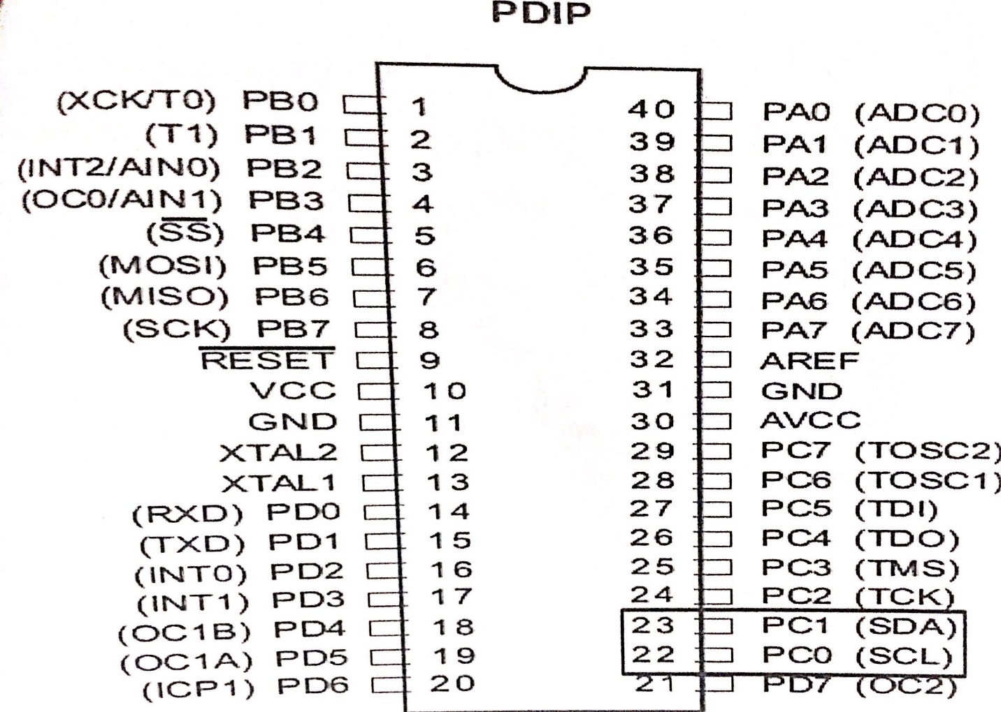**Module I2C**

* Inter Integrated Circuit (I2C) and also called two wire interface (TWI) since it uses only two wires for communication.
* Multi-Master Multi-Slave Bus.
* In I2C protocol communication always started by the master and in the case of multi-master, only one master have the ownership of the bus
* It widely used in fast and short distance communication like communicate between Microcontrollers and Sensors, EEPROM and LCD.
* The device that initiates a transaction on I2C bus is termed the master. The Master normally controls the clock signal. A device being addressed by the master is called a slave
* 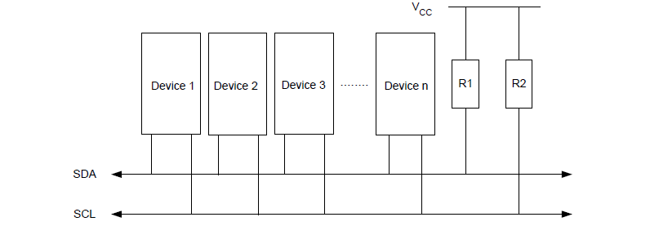In I2C, every data which is transmitted over the SDA line must be 8-bit longs. It is very important to remember in I2C that data bit is always transmitted from the MSB and we can send or receive any number of bytes in I2C between the start and stop condition. In I2C, one bit is always transmitted on every clock. A byte which is transmitted in I2C could be an address of the device

**Usage in our Project :**

It will be used to connect between the external EEPROM and the

Microcontroller. The controller will exchange information with the EEPROM

using I2C module.

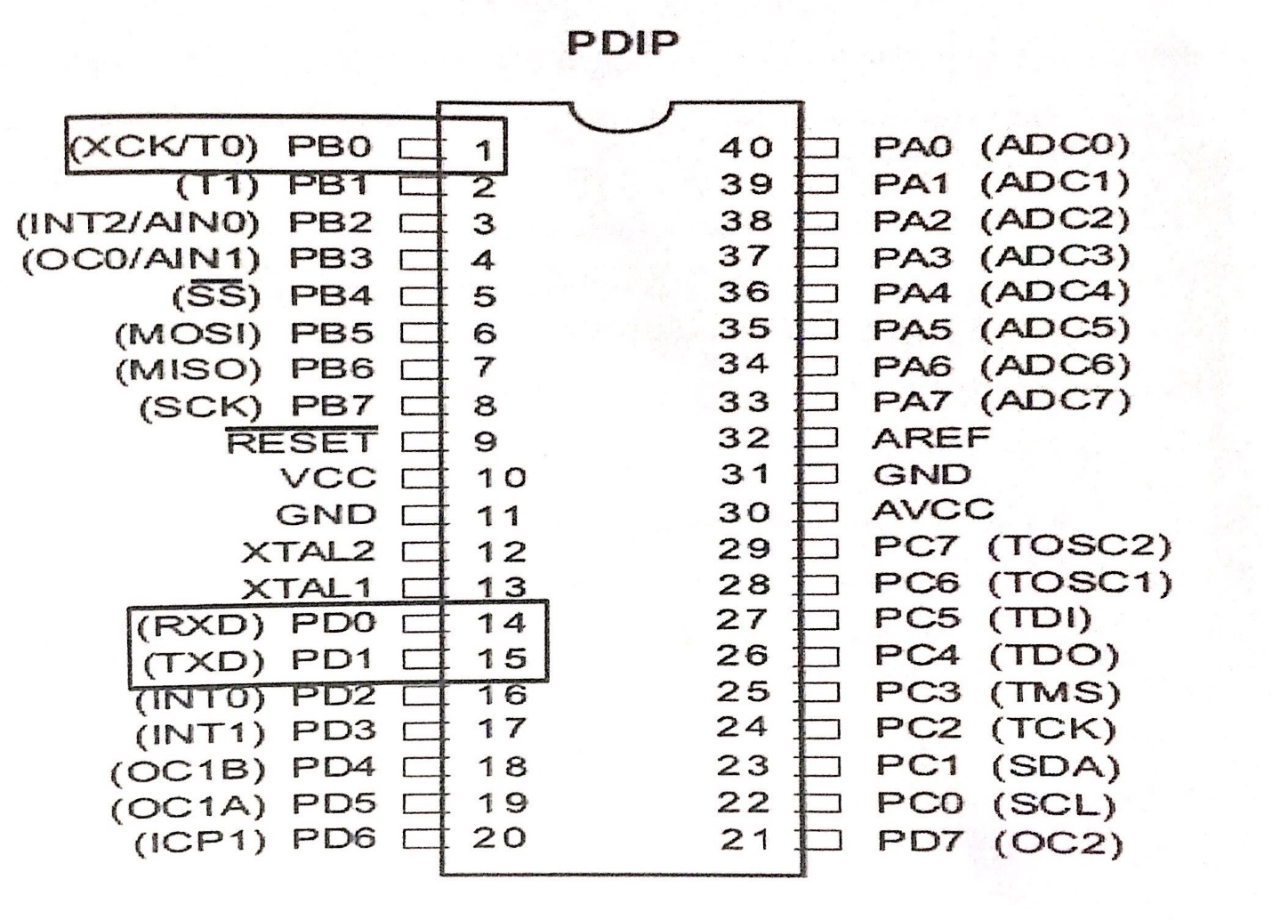**Module USART**

* Universal Synchronous Asynchronous Receiver Transmitter.
* Serial Full Duplex Communication. Both transmission and reception can occur at the same time
* 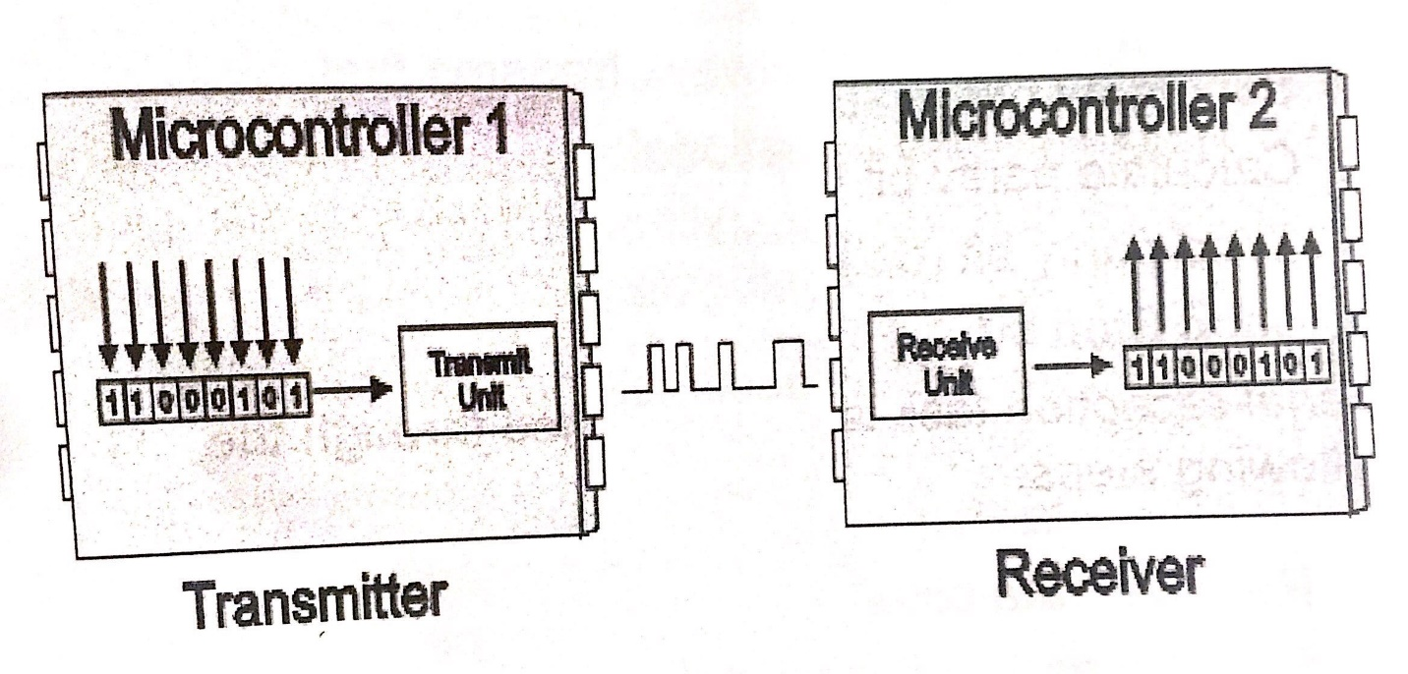The USART uses two I/O pins to transmit and receive serial data.

**Usage in our Project :**

- To communicate with other microcontrollers.

**EEPROM**

EEPROM (also E2PROM) stands for Electrically Erasable Programmable

Read-Only Memory and is a type of [non-volatile memory](https://en.wikipedia.org/wiki/Non-volatile_memory) used in computers,

integrated in [microcontrollers](https://en.wikipedia.org/wiki/Microcontrollers) for [smart cards](https://en.wikipedia.org/wiki/Smart_card) and [remote keyless system](https://en.wikipedia.org/wiki/Remote_keyless_system), and

other electronic devices to store relatively small amounts of data but allowing

individual bytes to be erased and reprogrammed.

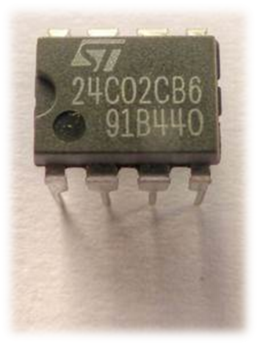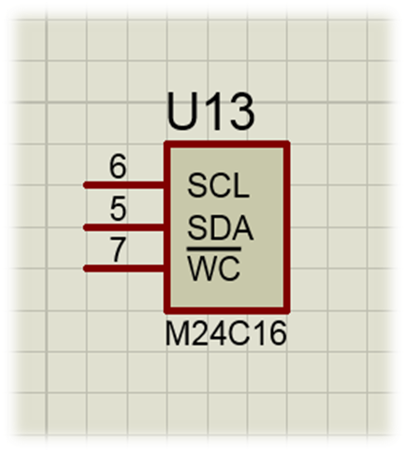

**Usage in our Project :**

It will be used to store the password of the locker and the doors. Also , it will

be used to store the prices of the products. Each product will have its own

barcode and price saved on the EEPROM. It will communicate with the

controller using the I2C module.

**KEYPAD**

This 16-button keypad provides a useful human interface component for

microcontroller projects. Convenient adhesive backing provides a simple way

to mount the keypad in a variety of applications.

Key Features:

* Excellent price-performance ratio
* Easy communication with any microcontroller

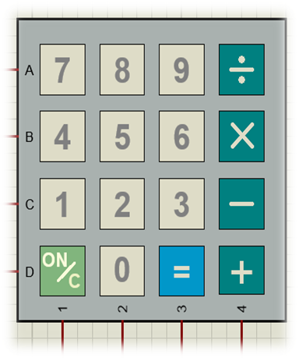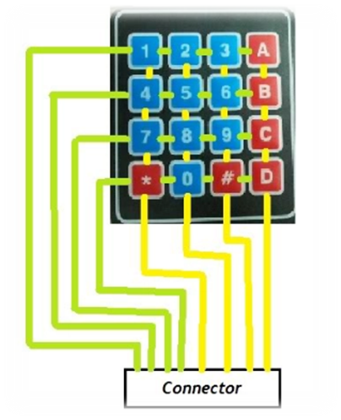

**Usage in our Project :**

It will be used as an input tool, customer can set or enter password through

this device. Also, the barcode is entered through this keypad. Can be an

input for the data to make some calculations on.

The entered data is processed by the microcontroller , and then it's wither

stored or used to make decisions.

**Non-Functional Requirements**

**Security**

- the software system needs a robust security mechanism to in place so that unauthorized users are not allowed access to parts of the system.

-the user of the system must be uniquely identiﬁed. This could be done by using a user name and associated password scheme that would authenticate and authorize the user access to the system and, if applicable , grant the user access to restricted or controlled parts of the system.

-if a user cannot be identiﬁed, he/she will be given “anonymous” access with read-only capabilities. In order to monitor all past access to the system ,all attempts to the access the system must be logged.

-the admin only can change the password with another password (admin password) and staff can only access the system for sales, service and reporting.

**Usability**

- The system must be simple where anyone can have a simple background for English language and calculations, dealing with it.

- The system’s user interface intuitive, easy to use and provide an overall positive user experience.it do what the user expect it to do, Tell the user of its current state , and when something goes wrong it explain the problem in a meaningful context that is understandable by the user and guidance toward correcting the problem.

**Performance**

- The system must be interactive and the delays involved must be less .So in every action-response of the system, there are no immediate delays.

**Technology**

- the system consist of microcontroller , LCD and kay Pad .the system should has clean software .

**Development**

-It is important that the system is easy to develop later , The code must therefore be clear and scalable.

**Delivery**

- The project will be delivered in the form of a box showing the LCD and the keypad .

**Operation**

-The system operation should be simple and integrated.

**DOMAIN REQUIREMENTS**

Our cashier system can be used in different supermarkets; so there’re some constraints should be taken into consideration during the development process to make it clear enough for the developer engineer.

**First constraint:**

* The microcontroller on AVR based board has EEPROM: memory whose values are kept when the board is turned off (like a tiny hard drive). This enables you to read and write those bytes. The supported micro-controllers on the various boards have different amounts of EEPROM: 1024 bytes on the ATmega328P, 512 bytes on the ATmega168 and ATmega8, 4 KB (4096 bytes) on the ATmega1280 and ATmega2560

**Second constraint:**

* For the I2C the hardware complexity increases when number of master/slave devices are more in the circuit. It is half duplex mode of communication.

The protocol is managed by software stack. This increases processing overheads on the µP and µC.

**Third constraint:**

* For the UART It is suitable for communication between only two devices.
* It supports fixed data rate between devices wanting to communicate otherwise data will be garbled

**Forth constraint:**

As we have more than one communication system in our project, It’s constrained that any communication system has short range wired communication to prevent data corruption

**System Interfaces**

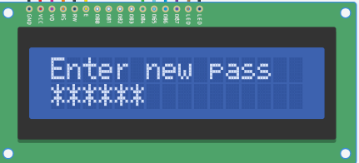**User interface**

* Inter new password using the keypad and displaying it on the LCD
* 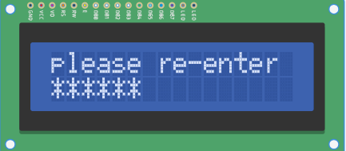confirming the pass by re-entering it , if matching, save the password and go to main menu.

If mis-matching ,repeat enter new password

* 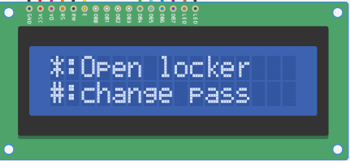this is the system main menu, if “*”, opens locker.

If “#”, changes the password.

* 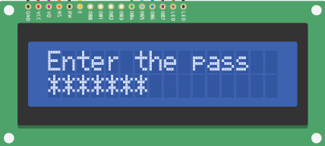Open locker condition, entering the password.

if matching, opens the locker for 20 sec and closes it

if mis-matching 3 times, locks system and buzzers for 1.5 min.

* 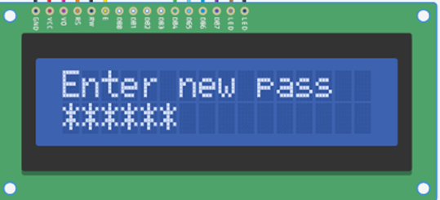Change password condition, repeating step 1

**Communication interface**

Communication between first microcontroller and second microcontroller atwhichthe first microcontroller connected with Keypad and LCD for cashier system to when enter the password more than three times wrong the first microcontroller send a signal to second microcontroller that there is one try to hack the system

Second micro sends to the buzzer which emits a beep.